Study on Wet Cleaning Solutions Behavior on the Wafer Surface during the Single Cleaning Process

Chengxi Yao ¹, Kihong Park ¹, Jinhyoung Lee ¹, Pengzhan Liu¹, Sanghuck Jeon¹ and Youngki Ahn ^{2†}

¹ School of Mechanical Engineering, Sungkyunkwan University, Suwon, Republic of Korea
Tel.:82-31-467-4852, E-mail: ykahn@daelim.ac.kr
² Dept. of Semiconductor Engineering, Daelim University College, Anyang-si, Republic of Korea

In this research, the behaviors of the wet cleaning solutions on the wafer surface during the single wafer cleaning process are studied with computational fluid dynamics (CFD) simulation via volume of fluid method (VOF). The 3-D transient simulation was performed for geometaries with different hight of the nozzle, properties of solution which are viscosity and contact angle with wafer surface, as well as different boundary conditions including flow rate, inlet temperature, and rotation speed of the wafer, respectively. The simulation results were analysed to study the mechanisms of how thickness and temperature distribution changed and influenced by the factors mentioned above. And the verification of simulation results which shows in Fig.1 with the observation results will be carried out in experimental set-up as Fig.2.

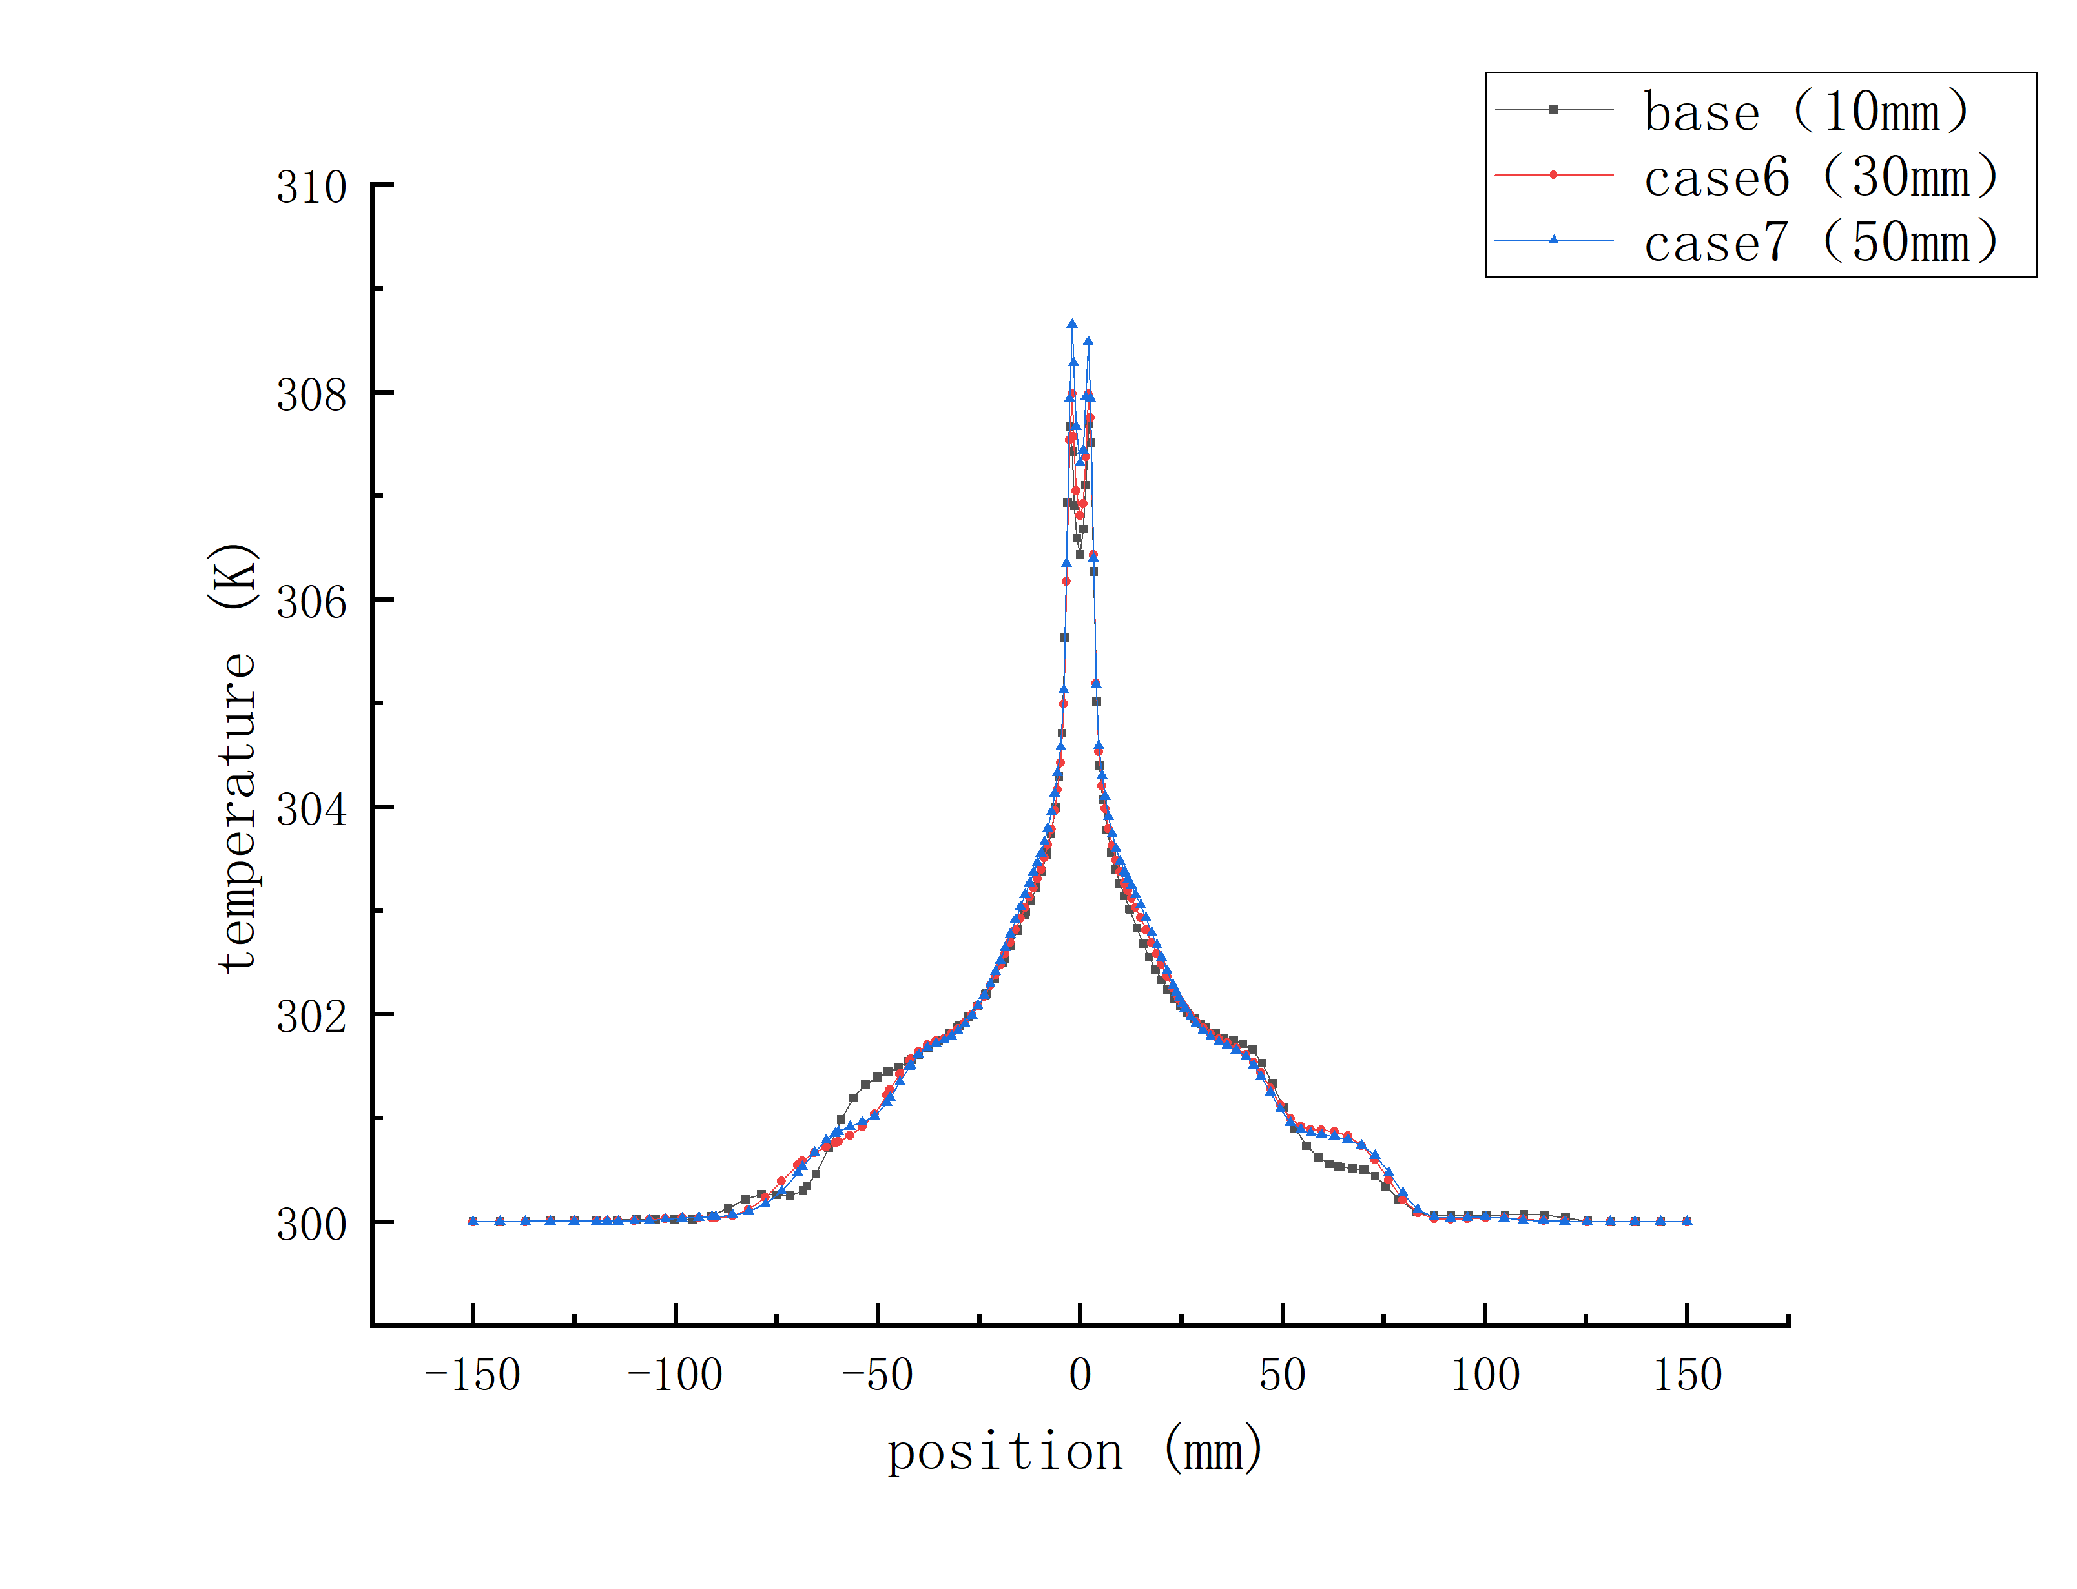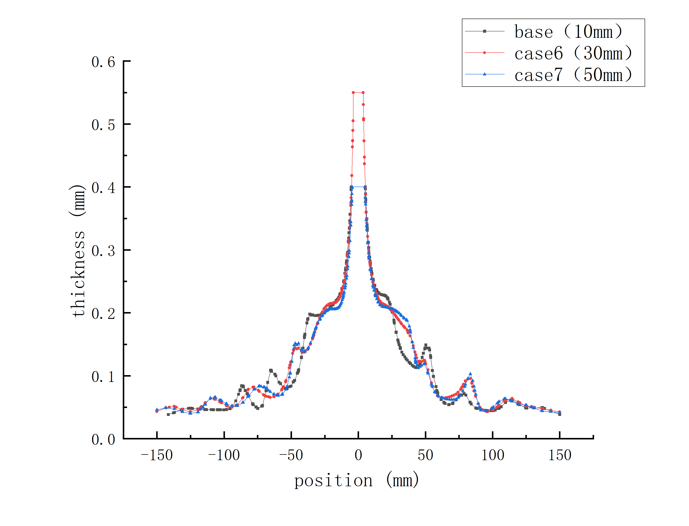
Fig. 1. Thickness distribution (left) and temperature distribution (right) line chart of wet cleaning solution at 1 sec. with different height of nozzle

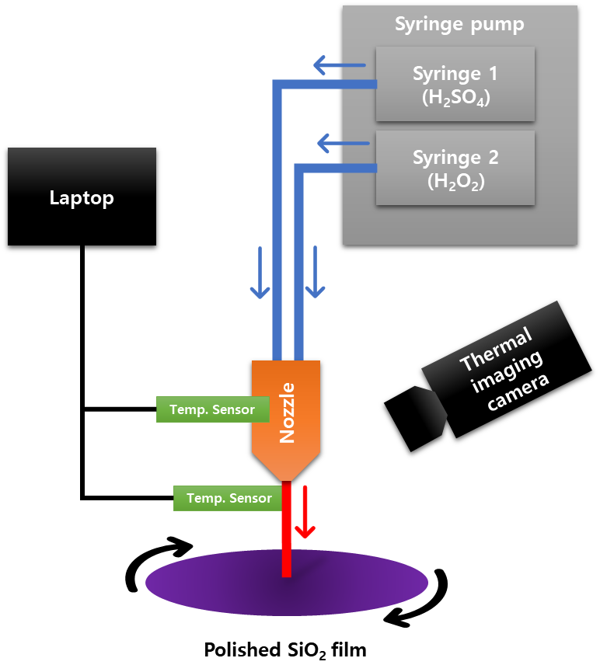
Fig. 2. In-situ monitoring system for observing the wafer surface and wet cleaning solutions simultaneously

References
1. H. Habuka, Journal of the Electrochemical Society, 158 (5), H487 (2011)
2. T. Hattori, Nonaqueous Cleaning Challenges for Preventing Damage to Fragile Nanostructures, p. 1-25 (2017)
3. P. W. Mertens, Solid State Technology, 45 (2), 51-54 (2002)
4. R. F. Reidy, Cryogenic Aerosols and Supercritical Fluid Cleaning and Surface Conditioning, p. 457-502 (2018)

